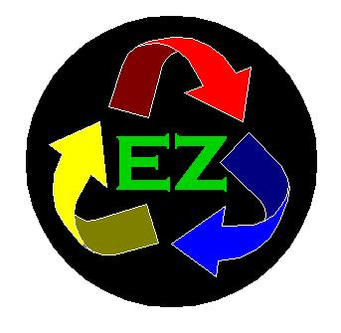
EZ Metals, LLC EZ Recycling, LLC
2150 W. Broadway 1315 N. 19th Ave.
Phoenix, Az Phoenix, Az
Office: 602-276-0425 Office: 602-253-2336
Fax: 602-276-0458 Fax: 602-254-3370
www.RecyclingMadeEZ.com

EZ REGISTRATION FORM

Account #________ Date: ________

Company Name: _________________________________________________________

Main Location: __________________________________________________________

City: ____________ State:_____ Zip Code: __________

Federal Tax ID/EIN: __________________________________________

Primary Contact: _____________________________________________
Name Title

_____________________________________________
Phone # Email

Other Rep: __________________________________________________
Name Title

_____________________________________________
Phone # Email

Payment Method: _____ Cash
_____ Check mailed to company address
_____ Hold payment to be picked up by ________

